**Team Good Friends**

**Proposed Level: Apollo 11**

**Motivation**

For many people, programming sounds like a complex field and often being stereotyped as the field for “nerds”, “geeks”, and “professional-only”. Nowadays, to popularize the use of programming, many websites and applications were created to help beginners familiarize with designing logical algorithms as well as practicing writing pieces of code, which provide great help for prospecting programmers.

In spite of those efforts, a lot of websites and apps lack the required user-friendly interaction to attract more hesitant or fastidious learners. For example, some utilize grid-in answer boxes rather than multiple-choice questions, discouraging users who have less time and concentration for learning. Also, we can introduce a form of leaderboard to encourage users to promote active-learning, which will lead to achievements or prizes.

**Aim**

We want to create an app which will help users to get used to coding concepts and languages easier than all existing solutions. In addition, the app will include a PvP mode and (potentially) a leaderboard to encourage people to learn faster in the mean of challenging friends and other learners.

**User stories**

* As a beginner who have zero knowledge about programming, I want a platform which is friendly for newcomers.
* After going through some training in coding, I want to hone my skills in a more pro-active way, rather than just studying.
* As an aspiring programmer, I want to try out my ideas and discuss them with other colleagues and friends. In addition, I would like to seek for interesting problems to test my abilities in problem-solving and code writing.

**Scope of project**

1. **Abstract:**

A web app including three main sections:

* Classroom: User can do mini-quizzes to learn and memorize code fragments and rules for multiple languages. After certain lessons, they can do a test to finish that section and move on. In addition, a reference library will be given for newcomers to read. Offered languages: Java, Python, C++
* Battleground: For users to test their abilities against other users, using a timed leaderboard.
* Sandbox: Free sharing and creating playground for users to test their ideas and explore possibilities.

The app will include a database of lessons, questions, and user-control server. An achievement system maybe implemented.

1. **Features included for June:**

* Classroom: lessons, tests.
* Battleground (as described above).
* Content database (quizzes, reference lib, tests’ questions, etc.).
* User database & login protocols
* UI/UX design completion.

1. **Features included for July:**

* Expanded content database.
* Sandbox mode.
* Achievements and leaderboard for Battleground.

**Technologies**

* Backend: Python
* Front-end: HTML – CSS – JavaScript, Flask, React
* Deployment: Heroku
* Account authorization: Email, Google, Facebook

**Program flow**

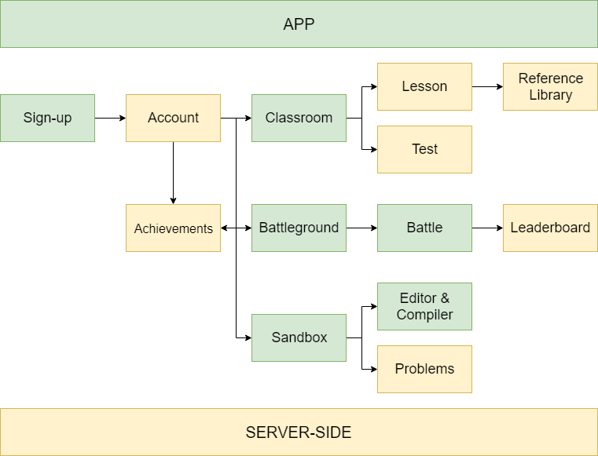

**Comparison to similar existing platforms**

* SoloLearn:

+ Too heavy on pure knowledge, deterring newcomers.

+ Grid-in questions are not the optimal question type for beginners (in our opinion). Instead, we will utilize MCQs to create quicker quizzes and incentivize users to take guesses and memorize syntaxes & code fragments.

* W3Schools:

+ Simple design, detailed knowledge. However, their examples and quizzes are fairly easy and lack diversity.

+ There is no users battleground like SoloLearn.

+ There is no discussion forum/development ground for users.

* GitHub/StackOverflow:

+ Are not officially “learning platform”.

+ Do provide a great forum and knowledge storage, however, the questions and problems are too difficult and complex for beginners.

**Features as of Milestone 2:**

* A functional front-end app with two main features being ‘Classroom’ and ‘Sandbox’ (React):

+ ‘Classroom’: Three programming languages, each with several ‘levels of knowledge’ and tons of quizzes to complete and learn from.

+ ‘Sandbox’: A multi-language editor and compiler for users to try-out their ideas and getting rid of several editors for specific languages.

* Database of questions for ‘Classroom’ and ‘Battleground’. (MySQL)
* An authentication service for users to login and out of the application. (Python – Flask)

**Current difficulties:**

* We are currently having troubles with connecting our authentication with the actual app since the authentication was written with Flask, and the app itself was written with React.
* Currently the interface is still too simple (virtually no pictures and simple buttons). We will try to improve it to create a more game-like feel for the app in order to attract users.
* Our ‘Classroom’ is only providing quizzes for users to start with (similar to Duolingo). However, this is not good for newcomers because they lack the knowledge and skills to complete some of the questions. Therefore, we are working on a way to introduce a knowledge library into ‘Classroom’ to provide sufficient knowledge of each level the user is on.
* We are moving the ‘Battleground’ feature to the final phase due to having problems with compiling and comparing answers to the test cases in the database.
* We also spent tons of time learning about React and JavaScript, which both of us are not familiar with, thus a lot of the scheduling were postponed and pushed back to Milestone 3. We will try to reschedule our plan accordingly and properly with the current situation**.**

**Testing and debugging:**

* We have asked our Computing student friends from several schools to do some testing on the app and the questions in the database. Overall, testers gave good feedbacks on our ideas and execution of the quizzes. However, they also mentioned about the lack of UI and base knowledge for beginners, which are the parts we are trying to get it right in Milestone 3.
* We encountered a lot of bugs with connecting the app and authentication because the two parts were written on two different platforms, thus making it more tedious.

Overall, we have (somewhat) completed the main feature being a functional ‘Classroom’ for users to complete multiple-choice quizzes and learn from the answers. However, we need to address further a lot of problems, as mentioned above. The current state of the app will be presented in the video.

**Features for Milestone 3:**

* A knowledge library in the ‘Classroom’ for beginners to read more about the current level before doing the quizzes.
* Functional ‘Battleground’ with timer and leaderboard.
* A more complex and refined UI.
* Connected authentication to the main app.